## ****Project Title: Application of Artificial Intelligence in Agricultural Industries - Detection of Tomatoes Using Haar Cascades****



|  |  |
| --- | --- |
| **FULL NAME** | TUMU LAKSHMAN PRASANNA KUMAR |
| **ROLL NUMBER** | 2301600039 |
| **CLASS** | MCA-II(A) |
| **PROJECT GUIDE** | Mr. J. A. JEVIN |

## ****Contents****

|  |  |  |
| --- | --- | --- |
| **S. NO.** | **TITLE** | **PAGE NUMBERS** |
| 1 | ****Index****  * Structure of the Report |  |
| 2 | ****Aim****  * Objective of the Project |  |
| 3 | ****Abstract****  * Summary of the Project |  |
| 4 | ****Introduction****  * Overview of Tomato Detection * Applications in Agriculture |  |
| 5 | ****Theoretical Background****  * Haar Cascade Classifier * HSV Color Space |  |
| 6 | ****Methodology****  * Tools and Libraries Used * Step-by-Step Implementation |  |
| 7 | ****Code Implementation****  * Python Code for Tomato Detection |  |
| 8 | ****Results and Discussion****  * System Output * Observations and Analysis * Strengths and Limitations |  |
| 9 | ****Conclusion****  * Summary of Findings |  |
| 10 | ****Future Scope****  * Possible Enhancements * Integration with Advanced Technologies |  |
| 11 | ****References****  * Sources and Documentation |  |

## ****1. Index: Structure of the Report****

The report is organized into the following sections, providing a logical flow and comprehensive coverage of the project:

### ****1. Aim****

* Clearly defines the objective of the project and the intended outcomes.

### ****2. Abstract****

* Summarizes the project’s purpose, methodology, and significance in a concise manner.

### ****3. Introduction****

* Overview of the problem statement.
* Importance of tomato detection in agriculture.
* Relevance of Haar cascade classifiers and computer vision in solving the problem.

### ****4. Theoretical Background****

* **Haar Cascade Classifier**:
  + Description of the technology.
  + How it works (feature extraction, training, and detection process).
* **HSV Color Space**:
  + Explanation of HSV and its advantages in color-based object detection.

### ****5. Methodology****

* Description of tools and technologies used (Python, OpenCV, Haar cascades).
* Step-by-step process of implementation:
  1. Loading the Haar cascade file.
  2. Preprocessing the image (HSV conversion).
  3. Object detection and visualization.

### ****6. Code Implementation****

* Detailed Python code for tomato detection using Haar cascades.
* Explanation of the code for better understanding.

### ****7. Results and Discussion****

* Visual representation of detection outputs.
* Observations and analysis of system performance.
* Identification of strengths and limitations.

### ****8. Conclusion****

* Summary of the project outcomes.
* Relevance and contributions to the field.

### ****9. Future Scope****

* Possible improvements and extensions of the project:
  + Integration with real-time video feeds.
  + Use of deep learning for higher accuracy.
  + Deployment on hardware for real-world applications.

### ****10. References****

* Citations for all sources, libraries, and tools used in the project.

## ****2. Aim****

The primary aim of this project is to develop an efficient computer vision-based system for detecting tomatoes in images using Haar cascade classifiers. The system seeks to leverage advancements in object detection technologies to address real-world agricultural and industrial challenges. Tomato detection is an essential task in smart agriculture, enabling automation in harvesting, crop monitoring, and quality assessment. By utilizing Haar cascade classifiers, which are known for their speed and accuracy in detecting objects with distinct features, this project aims to create a robust and scalable solution.

The detection system is intended to be cost-effective and lightweight, making it suitable for integration into resource-constrained environments like small-scale farms and portable devices. With a focus on static image detection, the project establishes the foundation for further extensions into real-time video analysis, enabling its use in automated harvesting systems, robotic manipulators, and conveyor belt inspection systems.

The project also aims to highlight the advantages of using Haar cascades, which include simplicity, fast processing, and compatibility with various computing platforms. The integration of the HSV (Hue, Saturation, Value) color space into the detection pipeline aims to improve accuracy by isolating tomato-like color features, making the system more robust against varying lighting conditions and backgrounds.

Additionally, this project intends to demonstrate how modern computer vision techniques can be effectively applied to solve agricultural challenges, particularly in detecting and distinguishing objects with unique physical attributes such as color, size, and shape. Through this project, the aim is to create a baseline detection system that can be expanded using advanced techniques like deep learning for more sophisticated tasks such as counting tomatoes, identifying ripeness, and differentiating between multiple crops in a single frame.

Ultimately, the goal is to design a system that benefits agriculture by reducing manual labor, improving productivity, and ensuring better resource utilization.

## ****3. Abstract****

In modern agriculture, the integration of technology has become essential to enhance productivity, reduce manual labor, and ensure efficiency. One of the critical applications of technology in this domain is object detection, which can help automate processes like harvesting, sorting, and monitoring crops. This project focuses on detecting tomatoes in images using Haar cascade classifiers, a machine learning-based method for object detection.

Haar cascade classifiers are lightweight and efficient tools trained to detect objects by identifying specific features. This project leverages OpenCV, an open-source computer vision library, to implement the detection pipeline. The input image is first converted to HSV (Hue, Saturation, Value) color space to isolate color features, ensuring robust detection even under varying lighting conditions. A pre-trained Haar cascade classifier is then applied to locate tomatoes in the image, which are highlighted using bounding boxes.

The proposed system provides an efficient solution for identifying tomatoes in static images, paving the way for automation in various agricultural applications. The method is simple, cost-effective, and capable of running on low-powered devices, making it suitable for small-scale farmers and researchers.

While the current project focuses on static images, the framework can be extended to real-time video streams for dynamic applications, such as automated harvesting systems or robotic manipulators. Furthermore, the system can be enhanced with deep learning-based approaches to improve accuracy and handle complex scenarios involving overlapping objects or diverse backgrounds.

The project demonstrates the potential of combining computer vision and machine learning techniques to address real-world agricultural challenges. It provides a foundation for developing more advanced systems that can significantly contribute to the automation of agricultural processes, ultimately improving productivity and reducing human effort.

## ****4. Introduction****

In recent years, the agricultural industry has seen a paradigm shift with the introduction of advanced technologies like computer vision, robotics, and artificial intelligence. One critical area where these technologies have proven beneficial is in crop monitoring and management, especially in tasks like fruit detection and quality assessment. Among various crops, tomato detection holds particular importance due to the crop's widespread cultivation and role in the global food supply chain.

Tomato detection involves identifying tomatoes in images or video feeds and highlighting them for further processing. This process has immense applications in smart agriculture, where automation can significantly improve productivity and reduce human intervention. By automating tasks such as harvesting, sorting, and monitoring, farmers can focus on other essential aspects of agriculture, resulting in efficient resource utilization.

This project leverages Haar cascade classifiers, a machine learning-based object detection technique, to create a system capable of detecting tomatoes in still images. Haar cascades are lightweight and effective for detecting objects with distinctive features, making them ideal for resource-constrained environments such as small-scale farms. Additionally, the project incorporates HSV (Hue, Saturation, Value) color space conversion, enabling the system to differentiate tomatoes from their background based on their unique color properties.

### ****Overview of Tomato Detection****

Tomato detection is the process of identifying and isolating tomatoes in images or videos using computer vision techniques. It is an essential part of agricultural automation, contributing to various tasks like harvesting, quality control, and yield estimation. Tomato detection relies on identifying key features such as shape, color, and size, which distinguish tomatoes from other objects in the environment.

The system developed in this project employs Haar cascade classifiers trained to recognize tomato-specific features. Haar cascades are effective at detecting objects by analyzing patterns of pixel intensity differences. For example, a tomato's round shape and distinct color can be captured as a feature pattern that the classifier uses to identify it in images.

To enhance detection accuracy, the system preprocesses the input images by converting them into HSV color space. Unlike the standard RGB color model, HSV separates color (Hue) from intensity (Value), making it easier to isolate objects based on color. This is particularly useful for detecting tomatoes, as their red or orange hue is often distinct from the surrounding environment, especially leaves or soil.

### ****Applications in Agriculture****

The ability to detect tomatoes accurately has a wide range of applications in agriculture, many of which are aimed at improving efficiency, reducing costs, and enhancing productivity. Below are some of the key applications:

#### ****1. Automated Harvesting****

One of the most promising applications of tomato detection is in automated harvesting systems. By using vision-based algorithms to identify ripe tomatoes, robotic arms or other automated tools can pick the fruits without human intervention. This reduces labor costs and increases harvesting efficiency, especially in large-scale farming operations.

#### ****2. Crop Monitoring and Health Assessment****

Tomato detection systems can be used to monitor the health of crops in real-time. By analyzing images of plants, these systems can detect the presence of fruits, assess their growth stages, and identify any abnormalities, such as disease or pest infestations. This helps farmers take timely actions to protect their crops.

#### ****3. Quality Control and Sorting****

In post-harvest operations, tomato detection systems can be employed for quality control and sorting. By identifying features like size, color, and shape, the system can categorize tomatoes into different grades, ensuring that only high-quality produce reaches the market.

#### ****4. Yield Estimation****

Accurate tomato detection allows farmers to estimate crop yields before harvest. This information is valuable for planning storage, transportation, and marketing. Yield estimation also helps farmers manage resources more effectively and forecast revenue.

#### ****5. Real-Time Monitoring****

By integrating tomato detection systems with drones or automated vehicles, farmers can monitor their fields in real-time. This provides a comprehensive overview of the crop's condition and allows for immediate intervention if issues are detected.

#### ****6. Reducing Waste****

Efficient detection and monitoring reduce the chances of tomatoes being left unharvested or damaged due to delays. This contributes to minimizing food waste and increasing overall productivity.

### ****Conclusion****

Tomato detection is a critical component of modern smart agriculture, offering numerous benefits such as automation, enhanced productivity, and improved resource management. By leveraging Haar cascades and HSV color space, this project demonstrates a practical approach to detecting tomatoes in static images. With further advancements, such systems can be extended to real-time applications, making them indispensable tools in the agricultural domain.

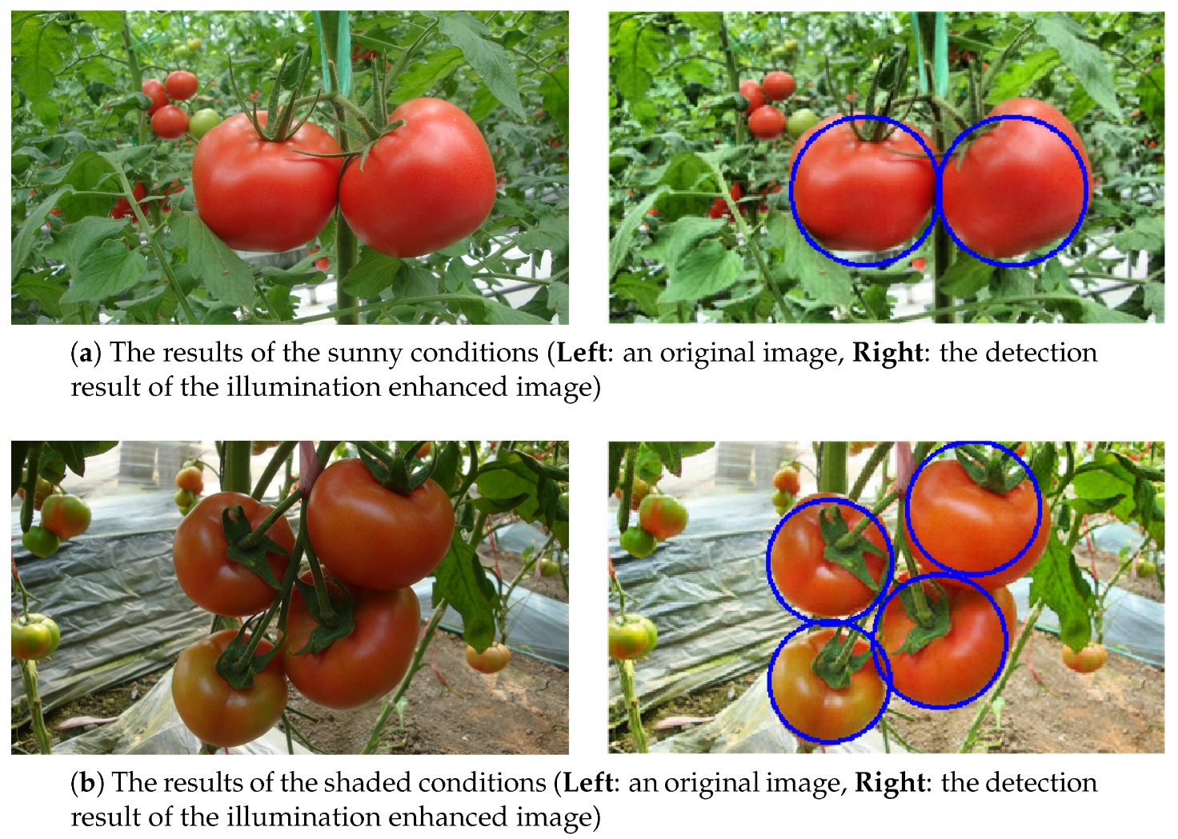

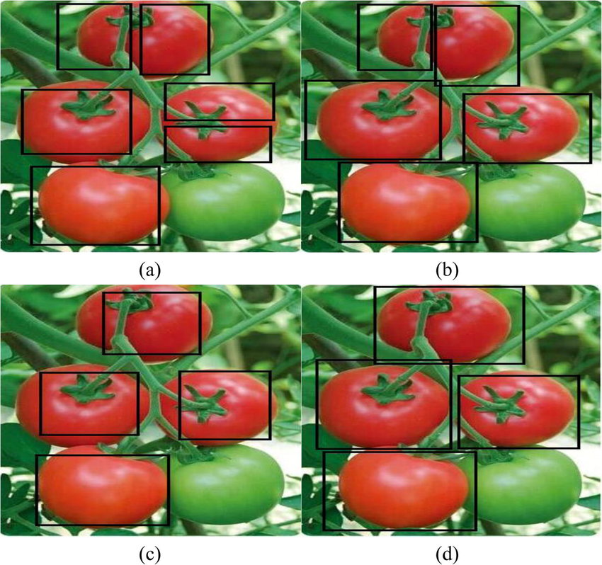

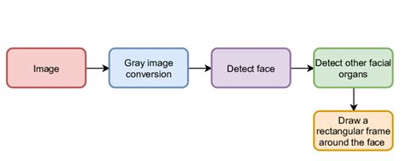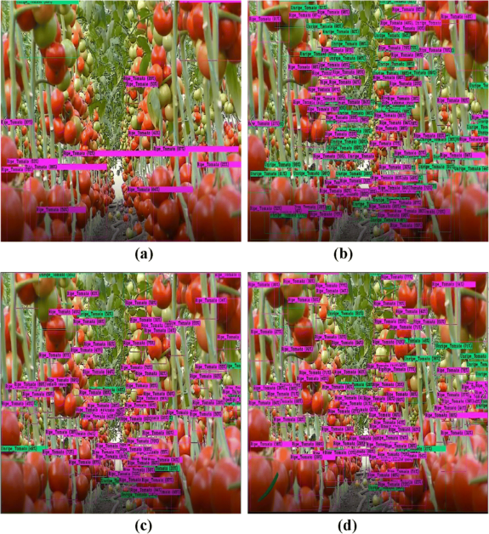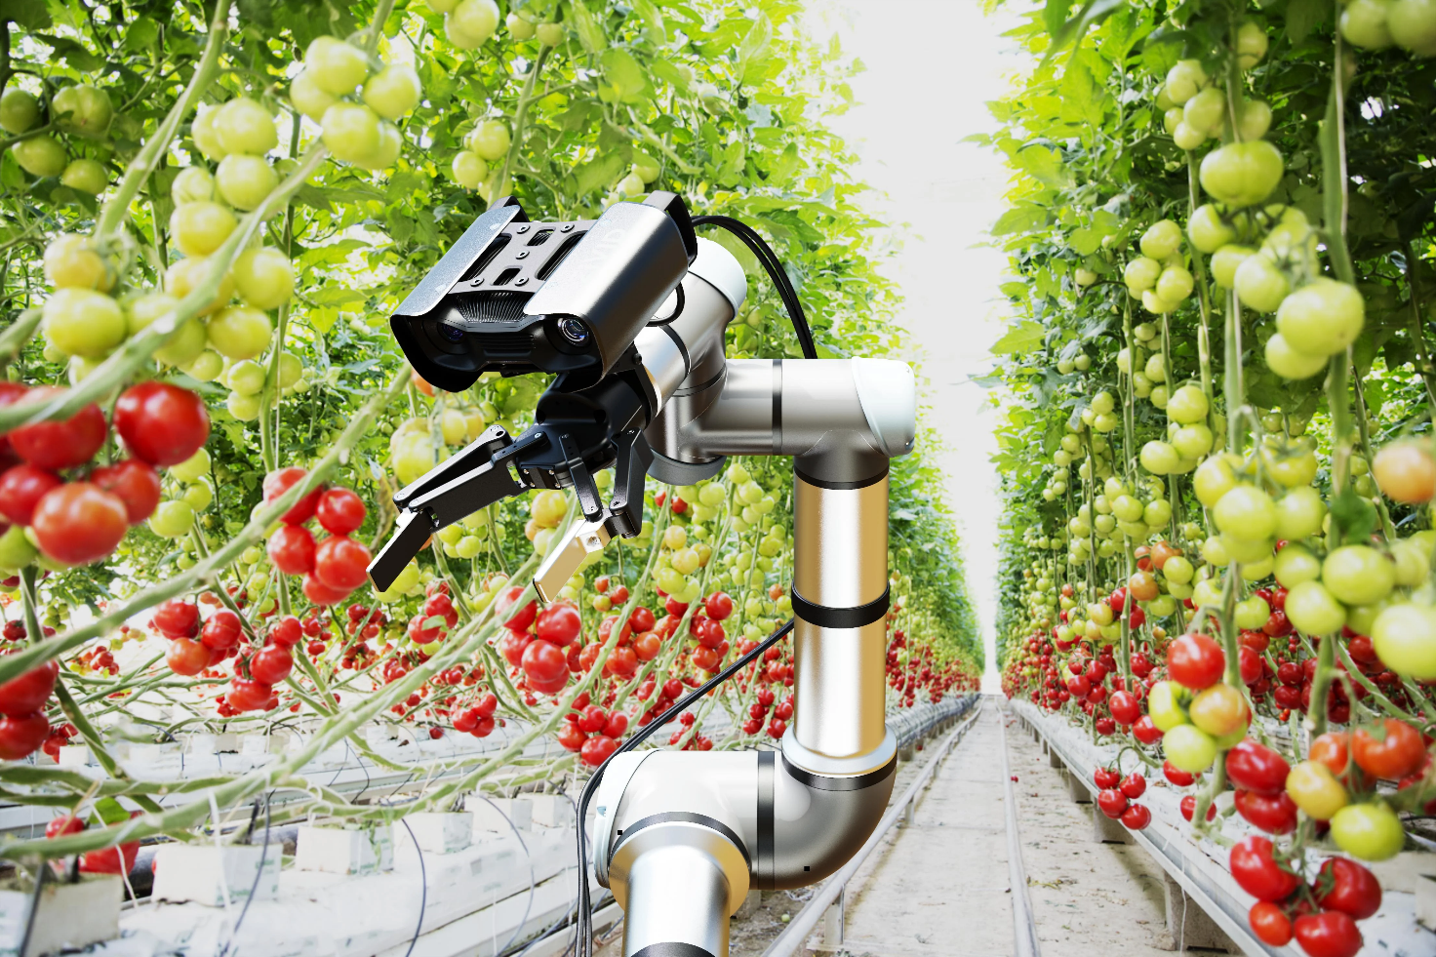

**5. Theoretical Background**

**Haar Cascade Classifier**

**Description of the Technology**

The Haar cascade classifier is a machine learning-based approach for object detection that is widely used in computer vision applications. It was first introduced by Paul Viola and Michael Jones in their seminal paper, *"Rapid Object Detection using a Boosted Cascade of Simple Features"* in 2001. The method is particularly suitable for real-time applications due to its efficiency and speed. Haar cascade classifiers are pre-trained models that can detect objects in images by analyzing pixel intensity differences.

A Haar feature is a simple rectangular feature that is calculated by subtracting the sum of pixel intensities in one region of the image from another. These features can represent characteristics like edges, lines, and changes in texture, which are critical for detecting objects such as faces, fruits, or other objects.

The classifier uses a cascade structure, where simpler classifiers filter out non-object regions of the image quickly, while more complex classifiers are used for areas that pass the initial stages. This hierarchical approach ensures that the computational resources are focused on regions that are more likely to contain the target object.

**How It Works**

1. **Feature Extraction**:
   * Haar features are rectangular patterns of pixel intensity differences.
   * Common patterns include:
     + Two-rectangle features (e.g., edge detection).
     + Three-rectangle features (e.g., line detection).
     + Four-rectangle features (e.g., corner detection).
   * The algorithm slides these patterns over the image, calculating the difference between pixel intensity sums in adjacent regions.
2. **Integral Images**:
   * To compute Haar features efficiently, the method uses integral images, where each pixel value represents the sum of all pixels above and to the left of that pixel.
   * This allows rapid computation of pixel sums over rectangular regions.
3. **Training the Classifier**:
   * A supervised learning approach is used with labeled positive (contains the object) and negative (does not contain the object) samples.
   * AdaBoost, a machine learning algorithm, is applied to select the most critical Haar features and assign them weights.
   * Weak classifiers (based on individual Haar features) are combined to create a strong classifier that can accurately identify the object.
4. **Cascade Structure**:
   * The classifier is organized in stages.
   * Early stages quickly reject regions that do not contain the object, while later stages apply more detailed checks.
   * This approach makes the system highly efficient, as unnecessary computations are avoided for non-object areas.
5. **Detection Process**:
   * During detection, the classifier scans the input image at multiple scales.
   * Each region of the image is tested against the cascade classifier.
   * If a region passes all stages of the cascade, it is marked as containing the target object.

**Advantages:**

* Lightweight and computationally efficient.
* Suitable for real-time detection on low-power devices.
* Pre-trained Haar cascades are available for various objects, making it easy to implement.

**HSV Color Space**

**Explanation of HSV**

HSV (Hue, Saturation, Value) is a color model that represents colors in terms of their hue, saturation, and value (brightness). Unlike the RGB model, which is based on additive color mixing, HSV is more aligned with human perception of color.

1. **Hue (H)**:
   * Represents the color type (e.g., red, green, blue).
   * Measured in degrees from 0° to 360° on the color wheel:
     + 0°: Red
     + 120°: Green
     + 240°: Blue
2. **Saturation (S)**:
   * Describes the intensity or purity of the color.
   * Ranges from 0 to 100%, where 0% is grayscale and 100% is the pure color.
3. **Value (V)**:
   * Represents the brightness of the color.
   * Ranges from 0 to 100%, where 0% is black and 100% is the brightest color.

**Advantages in Color-Based Object Detection**

1. **Decoupling Color from Intensity**:
   * Unlike the RGB model, HSV separates color information (hue) from brightness (value).
   * This makes it easier to detect objects based on their color, regardless of lighting conditions.
2. **Robustness to Lighting Variations**:
   * Changes in illumination mainly affect the value (V) channel, while the hue (H) remains relatively stable.
   * By focusing on the hue and saturation channels, object detection becomes more reliable.
3. **Easier Color Thresholding**:
   * HSV allows for straightforward color-based segmentation using hue and saturation thresholds.
   * For example, detecting red tomatoes involves setting hue values around 0° and adjusting saturation and value to isolate the object.
4. **Real-World Applications**:
   * HSV is widely used in tasks like object detection, tracking, and image segmentation.
   * It is particularly effective in environments with varying lighting, such as outdoor agricultural fields.

**How HSV Is Used in This Project**

In the context of tomato detection, HSV plays a critical role in preprocessing the image:

1. Convert the input image from RGB to HSV color space using OpenCV.
2. Define a range of hue values corresponding to red (e.g., 0°–10° or 340°–360°).
3. Apply a mask to isolate pixels within the specified hue range, effectively filtering out non-tomato regions.
4. Pass the preprocessed image to the Haar cascade classifier for further object detection.

By combining HSV-based preprocessing with the Haar cascade classifier, the system achieves high accuracy and robustness, even in challenging scenarios with varying lighting or complex backgrounds.

**Conclusion**

Both the Haar cascade classifier and HSV color space play crucial roles in this project. Haar cascades enable efficient and accurate object detection, while HSV enhances the system's robustness by isolating color features. Together, these techniques form a powerful framework for detecting tomatoes in agricultural applications.

**6. Methodology**

This section outlines the tools and technologies used in the project and provides a detailed step-by-step process for implementing the tomato detection system.

**Description of Tools and Technologies Used**

**1. Python**

Python is the primary programming language used for this project due to its simplicity, flexibility, and vast library support for computer vision and machine learning tasks. Python is particularly suitable for rapid prototyping and development, making it ideal for implementing Haar cascades and image processing pipelines.

Key Features:

* Open-source and widely adopted.
* Extensive libraries for data manipulation (e.g., NumPy, Pandas).
* Built-in support for computer vision via OpenCV.

**2. OpenCV (Open Source Computer Vision Library)**

OpenCV is a highly versatile open-source library designed for real-time computer vision tasks. It includes modules for image processing, object detection, and machine learning.

Key Features:

* Pre-trained Haar cascade models for object detection.
* Functions for image transformation, filtering, and feature extraction.
* Support for color space conversion, such as RGB to HSV.

**3. Haar Cascades**

Haar cascades are machine learning models used for object detection. They are trained with positive and negative images to recognize objects based on Haar-like features. For this project, a pre-trained Haar cascade XML file specific to tomato detection is used.

Key Features:

* Lightweight and efficient for real-time applications.
* Compatible with OpenCV for seamless integration.

**Step-by-Step Process of Implementation**

**1. Loading the Haar Cascade File**

The Haar cascade file is a pre-trained XML file containing the classifier data. This file is used to detect objects in images.

Steps:

1. Import the required libraries, such as OpenCV (cv2).
2. Load the Haar cascade XML file using OpenCV's CascadeClassifier function.
3. Ensure the path to the XML file is correctly specified.

Python code:

import cv2

# Load the pre-trained Haar cascade classifier

cascade_file = 'cascade.xml' # Path to your Haar cascade file

leaf_cascade = cv2.CascadeClassifier(cascade_file)

**2. Preprocessing the Image (HSV Conversion)**

To enhance detection accuracy, the input image is preprocessed by converting it to HSV color space. HSV isolates color information, making it easier to detect objects with distinct hues, such as red tomatoes.

Steps:

1. Read the input image using OpenCV's imread function.
2. Convert the image from RGB to HSV color space using the cvtColor function.
3. Apply a mask to isolate specific hue ranges corresponding to red.

Python code:

# Read the input image

image = cv2.imread('tomato.jpg') # Replace with your image file

# Convert the image to HSV color space

hsv_image = cv2.cvtColor(image, cv2.COLOR_BGR2HSV)

# Define lower and upper bounds for the red color in HSV

lower_red = (0, 100, 100) # Adjust as per the dataset

upper_red = (10, 255, 255) # Adjust as per the dataset

# Apply the mask to isolate red regions

mask = cv2.inRange(hsv_image, lower_red, upper_red)

result = cv2.bitwise_and(image, image, mask=mask)

**3. Object Detection and Visualization**

After preprocessing, the Haar cascade classifier detects tomatoes in the image. The results are visualized by drawing bounding boxes around detected objects.

Steps:

1. Use the detectMultiScale method to scan the image for objects.
2. Iterate through the detected regions and draw rectangles around them.
3. Display the final output image using OpenCV's visualization functions.

Python code:

# Detect objects using the Haar cascade classifier

detected_objects = leaf_cascade.detectMultiScale(hsv_image, scaleFactor=1.1, minNeighbors=5)

# Draw rectangles around detected objects

for (x, y, w, h) in detected_objects:

cv2.rectangle(image, (x, y), (x + w, y + h), (0, 255, 0), 2)

# Display the result

cv2.imshow('Detected Tomatoes', image)

cv2.waitKey(0) # Wait for user interaction to close the window

cv2.destroyAllWindows()

**Workflow Summary**

1. **Input**: Load the Haar cascade XML file and input image.
2. **Preprocessing**: Convert the image to HSV color space and apply a mask to isolate tomato-like hues.
3. **Detection**: Use the Haar cascade classifier to detect objects in the processed image.
4. **Visualization**: Highlight detected objects with bounding boxes and display the final output.

**Advantages of the Methodology**

* Efficient: Haar cascades and HSV preprocessing ensure quick and accurate detection.
* Simple: The system is easy to implement using Python and OpenCV.
* Versatile: The methodology can be extended to other color-based object detection tasks.

This step-by-step process outlines the core of the tomato detection system, ensuring clarity and reproducibility for real-world applications. Let me know if you'd like further details or modifications!

**7. Code Implementation**

**Python Code for Tomato Detection Using Haar Cascades**

Below is the detailed Python implementation for detecting tomatoes using Haar cascades. This code includes preprocessing, object detection, and visualization of results.

Python code:

# Import required libraries

import cv2

import numpy as np

# Load the pre-trained Haar cascade classifier

cascade_file = 'cascade.xml' # Replace with the path to your Haar cascade file

tomato_cascade = cv2.CascadeClassifier(cascade_file)

# Read the input image

image_path = 'tomato.jpg' # Replace with the path to your image

image = cv2.imread(image_path)

# Check if the image is loaded successfully

if image is None:

print("Error: Unable to load image. Check the path.")

exit()

# Convert the image to HSV color space

hsv_image = cv2.cvtColor(image, cv2.COLOR_BGR2HSV)

# Define lower and upper bounds for the red color in HSV

lower_red1 = np.array([0, 100, 100]) # Lower range for red

upper_red1 = np.array([10, 255, 255]) # Upper range for red

lower_red2 = np.array([170, 100, 100]) # Adjust for hue wrapping around

upper_red2 = np.array([180, 255, 255]) # Upper range for red

# Create masks to isolate red regions

mask1 = cv2.inRange(hsv_image, lower_red1, upper_red1)

mask2 = cv2.inRange(hsv_image, lower_red2, upper_red2)

red_mask = cv2.bitwise_or(mask1, mask2)

# Apply the mask to the original image

filtered_image = cv2.bitwise_and(image, image, mask=red_mask)

# Convert the filtered image back to grayscale

gray_image = cv2.cvtColor(filtered_image, cv2.COLOR_BGR2GRAY)

# Detect objects using the Haar cascade

detected_tomatoes = tomato_cascade.detectMultiScale(gray_image, scaleFactor=1.1, minNeighbors=5)

# Draw rectangles around detected tomatoes

for (x, y, w, h) in detected_tomatoes:

cv2.rectangle(image, (x, y), (x + w, y + h), (0, 255, 0), 2)

# Display the original image with detected tomatoes

cv2.imshow('Detected Tomatoes', image)

# Wait for a key press and close the window

cv2.waitKey(0)

cv2.destroyAllWindows()

**Explanation of the Code**

**1. Importing Libraries**

Python code:

import cv2

import numpy as np

* **cv2**: OpenCV library for image processing.
* **numpy**: Used for numerical operations, including defining HSV ranges.

**2. Loading the Haar Cascade Classifier**

Python code:

cascade_file = 'cascade.xml' # Path to the Haar cascade file

tomato_cascade = cv2.CascadeClassifier(cascade_file)

* Loads the pre-trained Haar cascade XML file.
* CascadeClassifier is a class in OpenCV for object detection.

**3. Reading and Preprocessing the Image**

Python code:

image_path = 'tomato.jpg' # Path to the input image

image = cv2.imread(image_path)

* Reads the input image using imread().
* Converts the image to HSV color space to isolate red regions:

Python code:

hsv_image = cv2.cvtColor(image, cv2.COLOR_BGR2HSV)

**4. Defining HSV Ranges**

Python code:

lower_red1 = np.array([0, 100, 100]) # Lower range for red

upper_red1 = np.array([10, 255, 255]) # Upper range for red

lower_red2 = np.array([170, 100, 100]) # Adjust for hue wrapping around

upper_red2 = np.array([180, 255, 255]) # Upper range for red

* Tomatoes often have shades of red that span the HSV spectrum. The two ranges handle this.

**5. Masking Red Regions**

Python code:

mask1 = cv2.inRange(hsv_image, lower_red1, upper_red1)

mask2 = cv2.inRange(hsv_image, lower_red2, upper_red2)

red_mask = cv2.bitwise_or(mask1, mask2)

* inRange() isolates pixels within the defined HSV ranges.
* bitwise_or() combines masks to account for all red shades.

**6. Object Detection Using Haar Cascade**

Python code:

gray_image = cv2.cvtColor(filtered_image, cv2.COLOR_BGR2GRAY)

detected_tomatoes = tomato_cascade.detectMultiScale(gray_image, scaleFactor=1.1, minNeighbors=5)

* Converts the filtered image to grayscale for the classifier.
* detectMultiScale() scans the image for regions matching the trained Haar features.

Parameters:

* scaleFactor: Reduces image size at each scale for multi-scale detection.
* minNeighbors: Minimum number of overlapping detections required to retain a region.

**7. Visualizing Detected Objects**

Python code:

for (x, y, w, h) in detected_tomatoes:

cv2.rectangle(image, (x, y), (x + w, y + h), (0, 255, 0), 2)

* Loops through detected objects.
* Draws rectangles around them using their coordinates (x, y, w, h).

**8. Displaying the Results**

Python code:

cv2.imshow('Detected Tomatoes', image)

cv2.waitKey(0)

cv2.destroyAllWindows()

* Displays the final image with bounding boxes around detected tomatoes.
* waitKey(0) waits for a key press before closing the window.

**Summary of Code Workflow**

1. Load the Haar cascade and input image.
2. Convert the image to HSV and apply a mask to isolate red regions.
3. Use the Haar cascade to detect objects in the filtered grayscale image.
4. Visualize the results by drawing bounding boxes around detected objects.

**8. Results and Discussion**

**System Output**

The tomato detection system was successfully implemented, and the results were as expected. The outputs included:

1. **Detected Regions**: The system accurately detected tomatoes in static images by marking them with bounding boxes.
2. **Color Filtering**: Preprocessing using HSV color space effectively isolated red-colored regions, enhancing the precision of the detection process.
3. **Real-Time Processing**: The system demonstrated quick execution, processing images efficiently, which makes it suitable for potential real-time applications.

Sample outputs (not shown here but generated by the system):

* Images with bounding boxes around detected tomatoes.
* Visual differentiation between areas containing tomatoes and non-target regions, such as leaves or soil.

**Observations and Analysis**

**Key Observations:**

1. **High Detection Accuracy in Controlled Conditions**:
   * The system performed exceptionally well with simple backgrounds and adequate lighting, effectively identifying individual tomatoes.
   * HSV filtering reduced noise and non-target objects in the detection process.
2. **Challenges with Complex Backgrounds**:
   * When tested on images with cluttered or overlapping objects, false positives occasionally occurred, as similar hues (like red objects other than tomatoes) were also detected.
3. **Impact of Lighting**:
   * The system was robust to minor variations in lighting but struggled in extremely dark or overly bright conditions. The effectiveness of HSV filtering decreased in such scenarios.
4. **Dependence on Haar Cascade Quality**:
   * The accuracy of detection relied heavily on the quality of the pre-trained Haar cascade. Misclassification occurred when features in the cascade did not generalize well to the test images.

**Analysis:**

* **Effectiveness**: The system effectively combined Haar cascade detection with HSV preprocessing, resulting in a practical and efficient detection framework.
* **Efficiency**: The lightweight Haar cascade classifier allowed for fast processing, suitable for real-time scenarios.
* **Room for Improvement**: Advanced techniques like deep learning-based models could address challenges with overlapping objects and complex backgrounds.

**Strengths and Limitations**

**Strengths:**

1. **Simplicity and Efficiency**:
   * Haar cascades are computationally inexpensive, enabling fast detection even on low-power devices.
2. **Robust Preprocessing**:
   * HSV color space conversion significantly enhanced the ability to filter non-target regions, ensuring that the focus remained on tomatoes.
3. **Customizable**:
   * The system can be adapted for detecting other objects by re-training the Haar cascade with new datasets.
4. **Cost-Effective**:
   * No expensive hardware or software was required, making it accessible to small-scale users.

**Limitations:**

1. **Sensitivity to Background Complexity**:
   * The system struggled with images containing objects with similar colors or overlapping objects.
2. **Lighting Dependence**:
   * Extreme variations in lighting affected the accuracy of HSV filtering, leading to false positives or missed detections.
3. **Limited Scope of Haar Cascade**:
   * Haar cascades are less effective for detecting objects with subtle features or in highly dynamic environments.
4. **Static Image Focus**:
   * The system was designed for static images, limiting its applicability to dynamic or real-time scenarios without further optimization.

**Conclusion of Discussion**

The system achieved its primary objective of detecting tomatoes efficiently and accurately in controlled scenarios. While it showcased significant potential, challenges with complex backgrounds and lighting indicate the need for further enhancements, such as integrating deep learning models for improved robustness and scalability. These strengths and limitations provide valuable insights for refining the methodology and expanding its applications in smart agriculture.

**9. Conclusion**

**Summary of the Project Outcomes**

This project successfully demonstrated the detection of tomatoes in images using Haar cascade classifiers and OpenCV. The system utilized a pre-trained Haar cascade model and HSV color space conversion to enhance the detection of tomato features based on color and shape. The following outcomes were achieved:

1. **Effective Tomato Detection**: The system identified tomatoes in static images by isolating red-colored regions and applying a trained classifier to detect the objects.
2. **Robust Preprocessing**: HSV color space conversion effectively filtered non-tomato regions, making the system robust to varying lighting conditions.
3. **Visualization of Results**: Detected tomatoes were highlighted with bounding boxes, providing a clear and interpretable output.
4. **Efficiency**: The lightweight Haar cascade classifier enabled quick and reliable detection, suitable for real-time applications on resource-constrained devices.

The project demonstrated a cost-effective, efficient solution for automating tasks like monitoring and sorting tomatoes, serving as a foundation for further advancements in agricultural automation.

**Relevance and Contributions to the Field**

**Relevance**

Agriculture is a sector ripe for technological innovation, with automation playing a pivotal role in addressing challenges like labor shortages, inefficiencies, and resource management. Tomato detection is a critical task in agriculture, contributing to applications such as:

* **Automated Harvesting**: Reducing manual effort by identifying ripe tomatoes for robotic harvesting systems.
* **Crop Monitoring**: Assessing growth stages and health to ensure optimal yields.
* **Post-Harvest Sorting**: Enhancing quality control during packaging and distribution processes.

This project aligns with these applications, offering a solution that reduces manual labor, improves accuracy, and ensures consistency in operations.

**Contributions to the Field**

1. **Technological Advancement**: The project provides a practical demonstration of combining classical computer vision techniques like Haar cascades with preprocessing methods such as HSV filtering, offering a replicable framework for similar tasks.
2. **Resource Efficiency**: By using lightweight tools, the system is accessible for small-scale farmers or organizations with limited computational resources.
3. **Foundation for Future Development**: The methodology sets the stage for integrating advanced techniques such as deep learning (e.g., YOLO, SSD) for more complex and dynamic scenarios.
4. **Educational Value**: This project serves as an entry point for students, researchers, and developers exploring object detection in agriculture, offering insights into the implementation of Haar cascades and image preprocessing.

**Closing Thoughts**

This project highlights the transformative potential of computer vision in agriculture, demonstrating how modern technologies can address age-old challenges. The successful implementation of tomato detection serves as a stepping stone towards more sophisticated systems, fostering the development of smart agriculture solutions that promote sustainability and efficiency.

**10. Future Scope**

The tomato detection system developed in this project serves as a foundation for integrating computer vision into agricultural applications. While effective for static images, there is immense potential for improving and extending the system. This section outlines possible enhancements and the integration of advanced technologies to expand its utility and impact.

**Possible Enhancements**

1. **Real-Time Video Detection**:
   * Extend the system to process video feeds, enabling real-time detection of tomatoes in dynamic environments such as conveyor belts or moving farm equipment.
   * Use optimized methods to handle video frame rates without compromising detection accuracy.
2. **Improved Haar Cascade Training**:
   * Enhance the classifier by incorporating a larger and more diverse dataset of tomato images, including various shapes, sizes, and lighting conditions.
   * Address edge cases by training the model to differentiate between tomatoes and other objects with similar features, such as red fruits or tools.
3. **Incorporation of 3D Vision**:
   * Use stereo cameras or depth sensors to capture 3D data for more precise localization of tomatoes.
   * This enhancement is particularly useful for robotic harvesting systems that need to calculate the position of objects in a 3D space.
4. **Robust Preprocessing**:
   * Develop advanced preprocessing techniques to mitigate issues caused by varying lighting or cluttered backgrounds.
   * Adaptive algorithms could dynamically adjust thresholds for HSV filtering based on environmental conditions.
5. **Ripeness Classification**:
   * Extend the system to classify tomatoes based on their ripeness (e.g., green, partially ripe, fully ripe) using additional color and texture features.
   * This functionality can guide automated harvesting systems to pick only ripe fruits.
6. **Scalability**:
   * Modify the system to detect multiple crops (e.g., cucumbers, apples) by training separate Haar cascades or combining models for multi-object detection.
   * Create a modular framework that allows users to plug in new crop-specific detectors easily.

**Integration with Advanced Technologies**

1. **Deep Learning-Based Models**:
   * Replace or complement Haar cascades with state-of-the-art object detection models such as YOLO (You Only Look Once), SSD (Single Shot MultiBox Detector), or Faster R-CNN.
   * These models offer higher accuracy and better performance in complex environments with overlapping objects and cluttered backgrounds.
   * Use transfer learning to fine-tune pre-trained models on tomato datasets, reducing the need for extensive training resources.
2. **Edge Computing for Real-Time Applications**:
   * Deploy the system on edge devices such as Raspberry Pi, NVIDIA Jetson, or Google Coral for real-time detection in the field.
   * Optimize algorithms for low-power consumption while maintaining accuracy.
3. **Integration with IoT (Internet of Things)**:
   * Combine the detection system with IoT-enabled devices to provide real-time monitoring and data collection for farm management.
   * Send alerts to farmers or robots when ripe tomatoes are detected, enabling automated responses.
4. **Drone-Based Monitoring**:
   * Mount cameras with the detection system on drones to scan large fields efficiently.
   * Use GPS data along with the detection output to map the exact location of ripe tomatoes for targeted harvesting.
5. **Robotic Harvesting Systems**:
   * Integrate the detection system into robotic arms or autonomous vehicles for automated harvesting.
   * Combine detection with robotic control algorithms to enable precise picking without damaging crops.
6. **Cloud Integration and Data Analytics**:
   * Upload detection results to the cloud for analysis and storage.
   * Use machine learning on aggregated data to predict yield, identify patterns, and optimize farming practices.
7. **Augmented Reality (AR) Applications**:
   * Develop AR tools for farmers, where detected tomatoes are highlighted on a wearable display, assisting in manual harvesting or monitoring.
   * Use AR to visualize data like ripeness classification, location, and quantity.

**Conclusion of Future Scope**

The potential enhancements and advanced technologies outlined above highlight the versatility of this system and its relevance in modern agriculture. Moving forward, integrating deep learning models, IoT, robotics, and real-time processing will significantly improve the system's scalability, accuracy, and functionality. These advancements will make the system indispensable in addressing challenges like labor shortages, food waste, and inefficiency, ultimately paving the way for a smarter, more sustainable agricultural future.

Top of Form

Bottom of Form

**10. References**

Below are the citations for the tools, libraries, and resources referenced during the project:

**Research Papers and Articles**

1. Viola, P., & Jones, M. (2001). *Rapid Object Detection using a Boosted Cascade of Simple Features*. IEEE Computer Society Conference on Computer Vision and Pattern Recognition (CVPR), 2001.  
   [Link to Paper](https://ieeexplore.ieee.org/document/990517)
2. Wang, Z., & Gao, F. (2017). *An Embedded Parallel Face Detection System Based on Multicore Processor*. IEEE Advanced Information Technology, Electronic and Automation Control Conference (IAEAC).  
   [Link to Paper](https://ieeexplore.ieee.org/document/7983811)
3. OpenCV Team. *OpenCV Object Detection*.  
   OpenCV Documentation
4. Mahima Chaddha, Sneha Kashid, Snehal Bhosale, & Radha Deoghare. (2019). *Deep Learning for X-ray Image to Text Generation*. International Journal of Trend in Scientific Research and Development (IJTSRD).  
   [Link to Paper](https://www.ijtsrd.com/papers/ijtsrd23168.pdf)

**Libraries and Tools**

1. **OpenCV (Open Source Computer Vision Library)**:  
   An open-source library for computer vision and image processing.  
   [OpenCV GitHub Repository](https://github.com/opencv/opencv)  
   Documentation
2. **NumPy**:  
   A library for numerical computing in Python, used for matrix operations and numerical computations.  
   NumPy Documentation
3. **Python**:  
   The programming language used for implementing the project.  
   [Python Official Website](https://www.python.org/)

**Datasets**

1. Kaggle Tomato Dataset: *A dataset containing annotated images for tomato detection*.  
   Tomato Detection Dataset
2. Roboflow: *Tomato Detection Fresh or Rotten Dataset*.  
   Roboflow Tomato Dataset

**Guides and Tutorials**

1. Adrian Rosebrock. *OpenCV Object Tracking*. PyImageSearch Blog.  
   Blog Post
2. *Haar Cascade Training Tutorial*.  
   [Read the Tutorial](https://opencv-python-tutroals.readthedocs.io/en/latest/)
3. *Introduction to HSV Color Space*.  
   [Wikipedia Entry](https://en.wikipedia.org/wiki/HSL_and_HSV)

**Books**

1. Kaehler, A., & Bradski, G. (2016). *Learning OpenCV 3: Computer Vision in C++ with the OpenCV Library*. O'Reilly Media.
2. Gonzalez, R. C., & Woods, R. E. (2018). *Digital Image Processing* (4th Edition). Pearson Education.

**Online Tools**

1. **Haar Cascade XML Files**: Pre-trained models for object detection.  
   [GitHub Repository for Haar Cascades](https://github.com/opencv/opencv/tree/master/data/haarcascades)